1. Indicate the name of the different brain lobes on this picture.

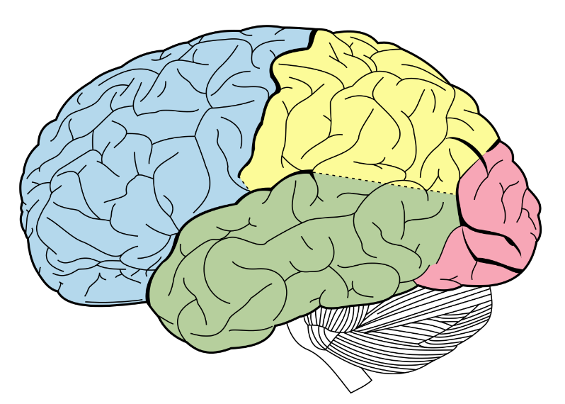

(wikipedia)

1. Indicate the 6 direction names used in anatomy on the picture above on the arrows
2. Which subcortical brain structure is central in emotion processing?
   1. Amygdala
   2. Striatum
   3. Hippocampus
3. Indicate the name of the different neuron part on this picture.

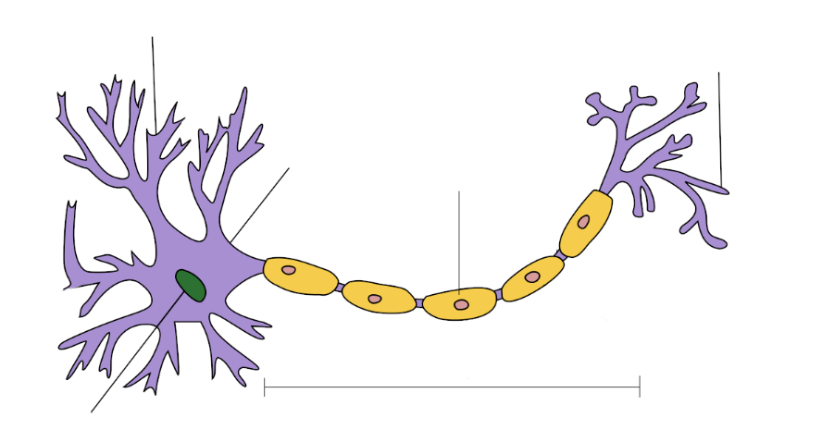(wikipedia)

1. Explain briefly what happens at the molecular level during excitatory synaptic transmission

(Ca ions, vesicules release neurotransmitter, neurotransmitter binds to receptors postsynaptic, Na goes in and K goes out, EPSP)

1. List some function of glial cells

(support, metabolism…)

1. Explain the idea of synaptic integration
2. What are the 3 divisions of the autonomic nervous system and their basic function
3. What is a true characteristic of the thalamus, is it…
   1. A relay for sensory information ?
   2. An interface with the hormonal system ?
   3. A center of executive functions ?
4. What are the 2 main phases of sleep and their main characteristic?
5. What are the common points and differences between neuronal and hormonal communication?
6. What signal does fMRI measure
   1. The summed up electrical activity of neurons
   2. The energy consumption of neuronal activty
   3. The magnetic field emitted from neuronal activity
7. Indicate the approximate temporal and spatial resolution of EEG, MEG, fMRI and PET
8. What hormone is involved in the circadian rhythm
   1. Melanin
   2. Melatonin
   3. Adrenalin
   4. Noradrenalin
9. Explain how NMDA receptors are coincidence detectors for plasticity
10. Indicate the different long term memory categories and subcategories
11. What is the different between operant and classical conditioning?